1. Find the ward no of all patient without duplicates.

select distinct ward_no from Ward

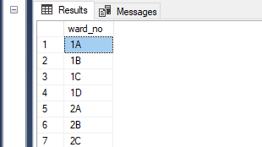

1. Find all patients in 1A no ward.

select Patient_name from Patient where Ward_no='1A';

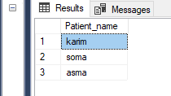

1. Find the names of all patients whose name includes the substring “islam”.

select Patient_name from Patient where Patient_name like '%islam%';

1. Sum of total bill of a patient.

select sum(Amount) from Bill;

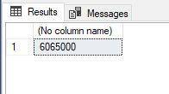

1. Find the total number of doctors whose assigned for patient in the “702”no ward.

select count(Assigned_doctor) from Patient where Ward_no='1A';

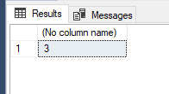

1. List all ward no along with the number of bed no in each ward.

select ward_no,bed_no from Patient;

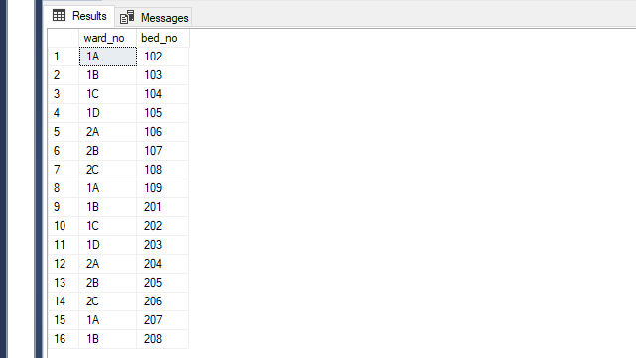

1. Find the total number of patient of “1A” no ward.

select count(distinct Patient_id) from Patient where Ward_no='1A';

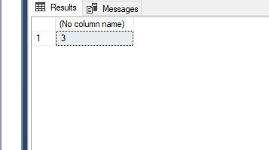

1. Find all ward no of burn category.

select all ward_no from Ward where Category='burn unit';

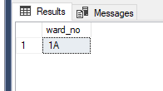

**College**(department,doctor,student,course,takes,teaches)

1. Find department name, building, budget/12 as monthly budget.

select Dept_name,Building,Budget/12 from Department;

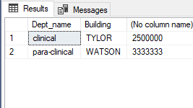

1. Find all students in clinical department with total credit>80

select stu_name from student where Dept_name ='clinical' and Total_credit>40;

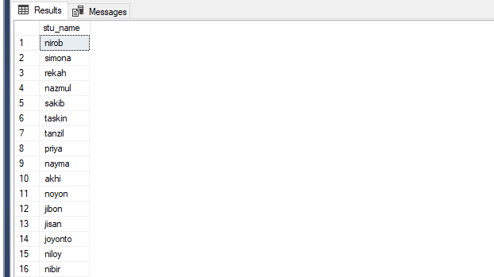

1. Find the names of all students in the non-clinical department who have took some course and the course id.

select stu_name,course_id from Student,Takes where Takes.Student_id= Student.Student_id and Dept_name= 'para-clinical';

1. Find the names of all doctors who have a higher salary than some doctors in clinical department

Select distinct D.Doc_name from Doctor as D,Doctor as S where D.Salary>S.Salary and S.Dept_name = 'clinical';

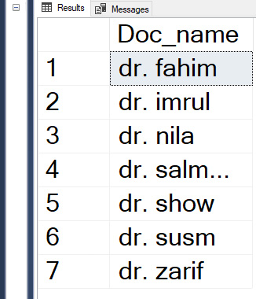

1. Find the names of all doctors with salary between 90000 and 100000.

select doc_name from Doctor where Salary between 90000 and 100000;

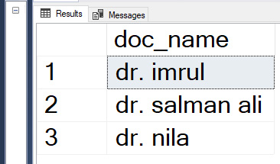

1. Find courses that teaches by doctors in 2011 or in 2012. (do this by union)

(select course_id from Teaches where Teaches_year = 2017) union (select course_id from Teaches where Teaches_year = 2018);

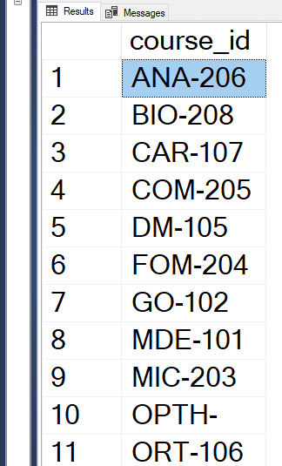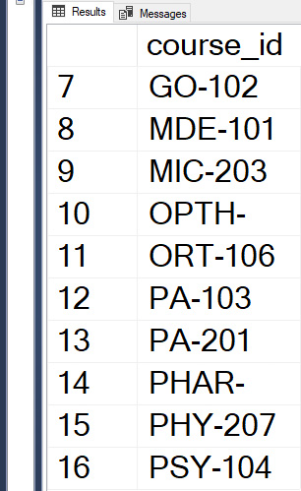

1. Find courses that teaches by doctors in 2009 and in 2010. (do this by intersect)

(select course_id from Teaches where Teaches_year = 2017) intersect (select course_id from Teaches where Teaches_year = 2018);

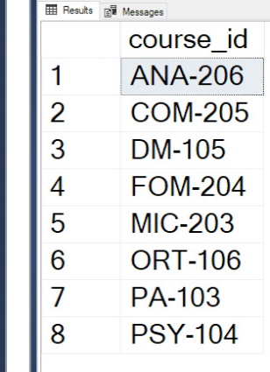

1. Find courses that takes by students in 2009 but not in 2018.(using except)

(select course_id from Teaches where Teaches_year = 2017) except (select course_id from Teaches where Teaches_year = 2018);

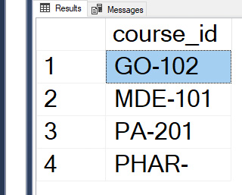

1. Find the salaries of all doctors that are less than the largest salary.

select distinct T.salary from Doctor as T, Doctor as S where T.Salary<S.Salary;

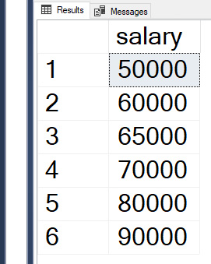

1. Find all the salaries of all doctors.

Select distinct salary from Doctor;

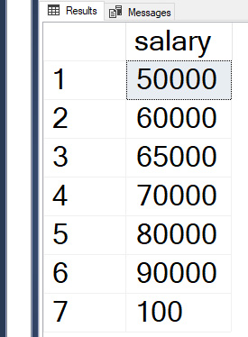

1. Find the maximum salary of doctors.

select max(salary)as Max_salary from Doctor;

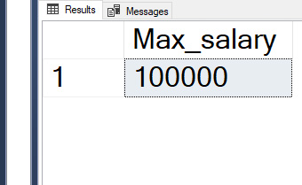

1. Find the total number of (distinct) students who have taken course taught by the doctor with ID 100…
2. Find names of doctor with salary greater than that of some (at least one) doctor in the non-clinical department.

select distinct T.Doc_name from Doctor as T, Doctor as S where T.Salary>S.Salary and S.Dept_name = 'para-clinical';

